**Experiment No:-7**

**Objective:-** To apply **Bayes’ Theorem** for estimating the **posterior probability and Principle Component Analysis.**

**Bayes’ Theory**

Bayes’ Theorem is a fundamental concept in probability theory and statistics that describes how to update the probability of a hypothesis based on new evidence. It allows us to calculate the posterior probability — the probability of an event occurring given that another event has already occurred.

The theorem is mathematically expressed as:

P(A∣B)=P(B∣A)⋅P(A)P(B)P(A|B)= \frac{P(B|A) \cdot P(A)}{P(B)}P(A∣B)=P(B)P(B∣A)⋅P(A)​

Where:

* P(A∣B)P(A|B)P(A∣B) = Posterior probability (probability of event A given event B)
* P(B∣A)P(B|A)P(B∣A) = Likelihood (probability of event B given event A)
* P(A)P(A)P(A) = Prior probability of event A
* P(B)P(B)P(B) = Total probability of event B

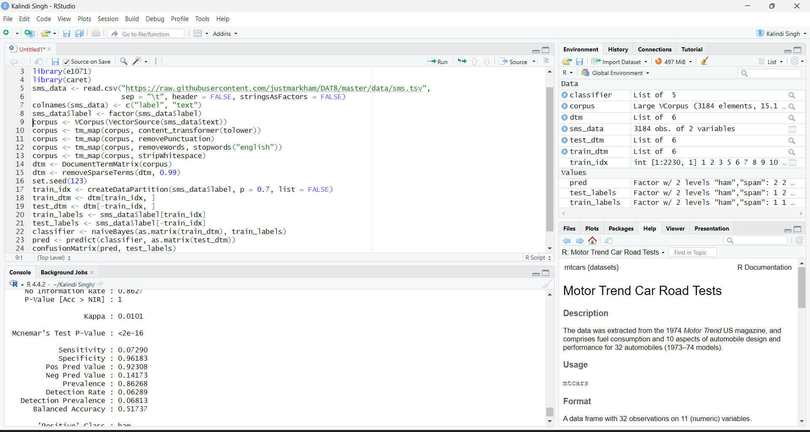

**Principle Component Analysis (PCA)**

Principal Component Analysis (PCA) is a statistical technique used for dimensionality reduction while preserving as much variance in the data as possible. It transforms the original set of correlated variables into a new set of uncorrelated variables called principal components. These components are ordered such that the first few retain most of the variation present in the original variables.

The key idea is to project high-dimensional data onto a lower-dimensional subspace to:

* Simplify analysis and visualization
* Reduce noise and redundancy
* Improve computational efficiency for machine learning tasks

PCA achieves this by:

1. Standardizing the data (if necessary)
2. Computing the covariance matrix
3. Extracting the eigenvalues and eigenvectors
4. Selecting top k principal components based on variance
5. Transforming the data into the new subspace



